
A 10
SET NO : 1

Sreenidhi Institute of Science & Technology
(An Autonomous Institution)
Code No: 101ME03

B. TECH. I – Year II – Semester Examinations, July/Aug, 2011 (Regular)
ENGINEERING MECHANICS (ME)

Time: 3 Hours Max. Marks : 70

Note : No additional answer sheets will be provided.

Part-A (Objective Type)
Max.Marks:20

Answer all QUESTIONS.

1. Differentiate moment of force and couple. Also mention two examples for each.

2. The resultant of two forces acting at an angle of 60⁰ is 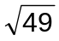. If they act at right angle their resultant would be 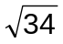. find the magnitude of the forces.

3. What is cone of friction?

4. Mention the importance of wedge friction.

5. Distinguish between method of joints and method of sections.

6. Define the terms centriod and centre of gravity.

7. Define the term polar moment of inertia and product of inertia.

8. State and prove perpendicular axis theorem.

9. What is meant by general plane motion?

10. Briefly describe work of the force of spring.
Part – B
Max. Marks: 50

ANSWER ANY FIVE QUESTIONS.
EACH QUESTION CARRIES 10 MARKS.

1. Three cylinders are piled up in a ditch. The surfaces of the ditch are smooth. Find reaction between cylinder A and the vertical wall. The weights of cylinders A,B,C are 60 N, 180N, and 100N respectively and radii 100 mm, 150 mm and 120 mm respectively.

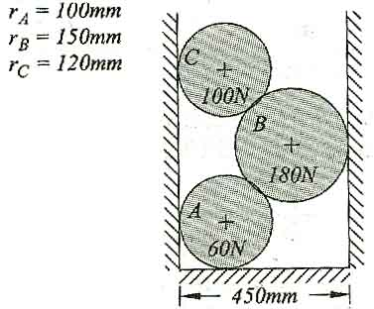

2. a) Determine the force P to be applied to the weightless wedges to start them under a 1000 N block. The coefficient of friction at all contact surfaces is 0.30. [ 6 ]
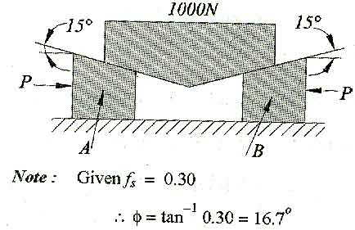
b) A rope is used to lift a 100N weight using locked pulley as shown in figure. If f_{s}= 0.30, determine force P necessary to begin lifting the load. [ 4 ]

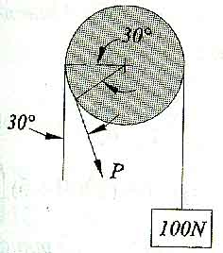

3. A hexagonal truss formed of 11 bars of 2m length each. It is hinged at one end and roller supported at the other end. Find the axial forces in the members CD and GB.
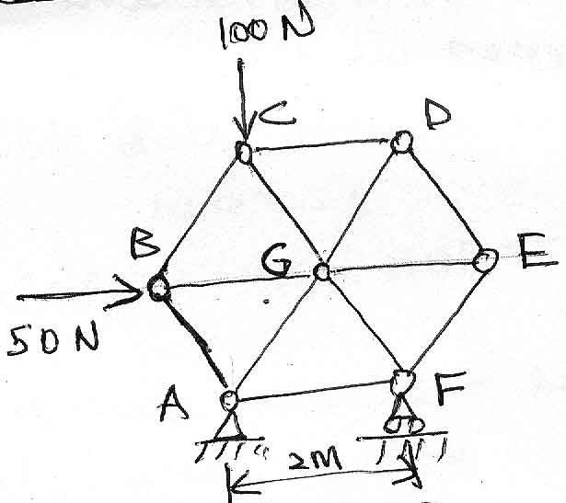
4. Determine the coordinates of the centroid of the shaded area formed by the intersection of a straight line and a parabola shown in the figure below. The equation of the parabola is given by 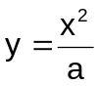 and of straight line by y=x.

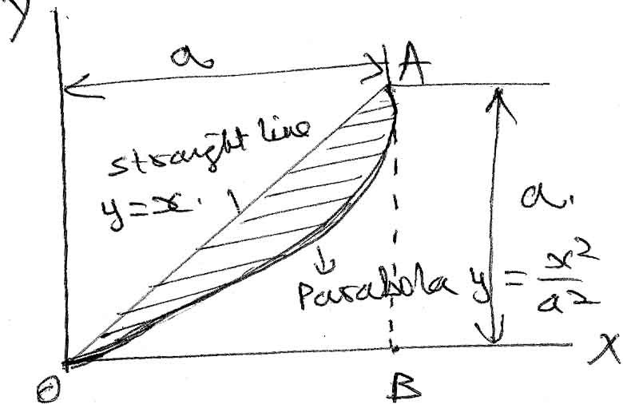
5. Compute the moment of inertia of the 100 mm X 150 mm rectangle shown figure below about x-x axis to which it is inclined by an angle θ = sin⁻¹ .
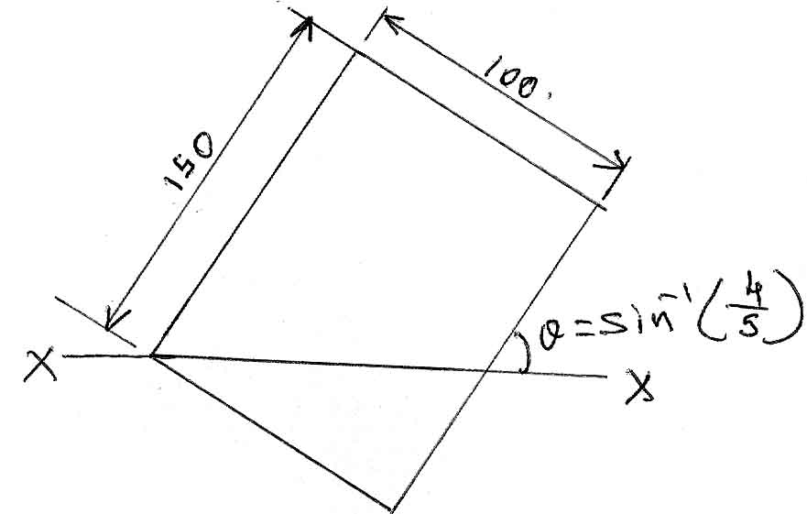

6. A bar AB of length 1m has its ends A and B constrained to more horizonally and vertically as shown in below figure below. The end A moves with constant velocity of 5 m/s horizontally. Find a) the angular velocity of the bar, b) the velocity of the end B and c) the velocity of the mid point C of the bar at the instant when the axis of bar makes an angle of 30⁰ with the horizontal axis.
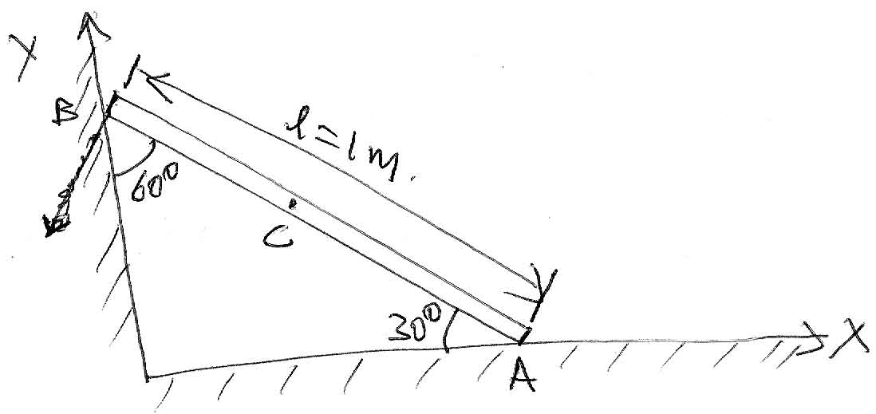

7. A wheel of radius 1.5m rolls freely to the right. At given position ω = 5 rad/s and α = 8 rad/s² both clockwise, compute velocity and acceleration of point B which is 0.5m from centre of the wheel.
α
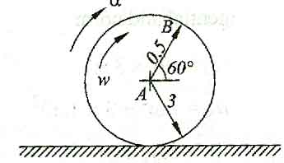

8. A block of weight 500N, starts from rest due to a force P = 1000N, and moves over a rough inclined surface as shown in figure below. After moving by 15m up along the incline, the force P is then removed. Find the velocity of block when it regains its original position.
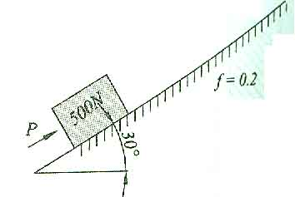

-- 00 -- 00 --

